**Meeting_5 Review Data flow diagram, Use case diagram, ER diagram**

DETAILS

* **Rough diagrams**
  + - Use case

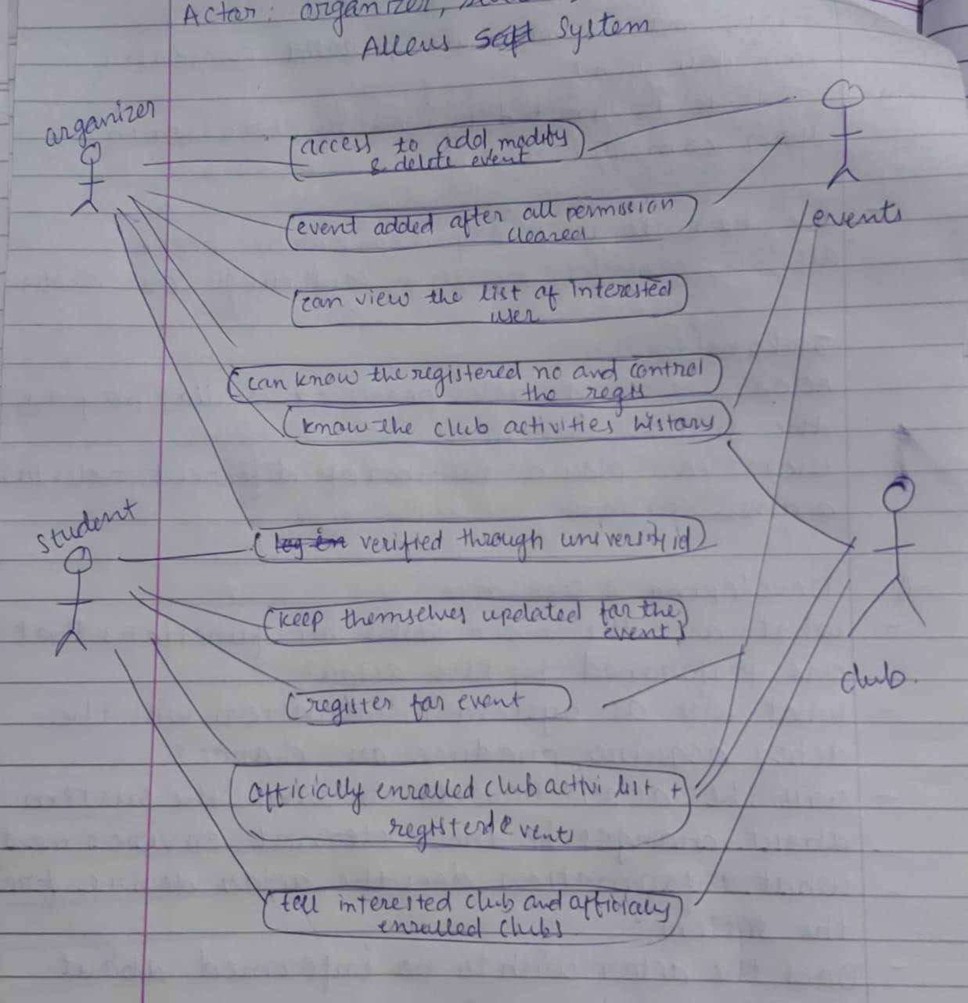

* + - Data flow diagram
      * + 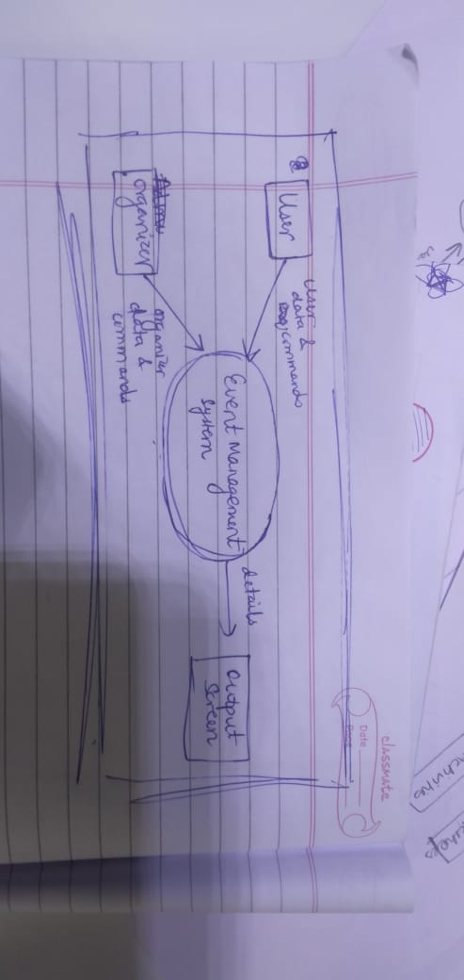
        + 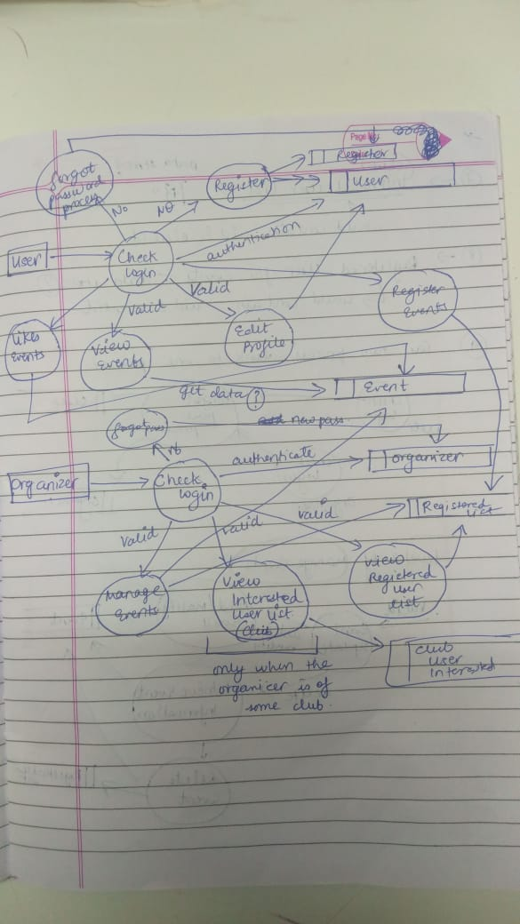

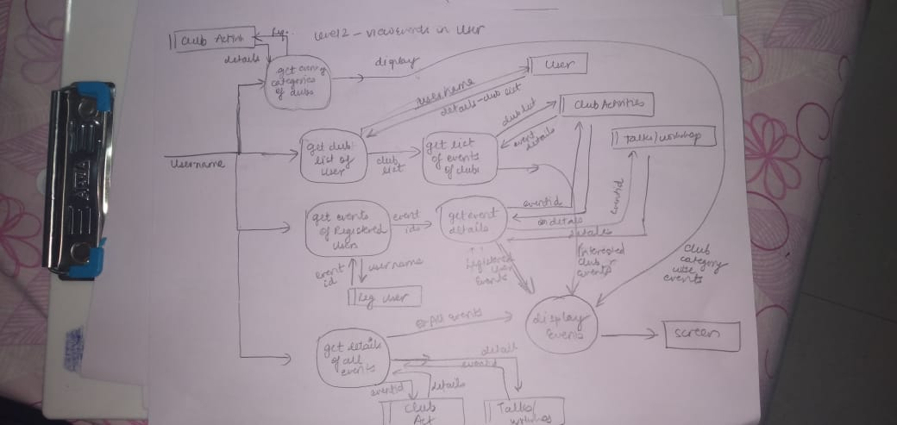

* + - Entity relationship (ER) diagram

